**‘Fresh install of django in virtual env**

Mkdir djangoProject

Cd djangoProject

Pip install virtual env

Virtualenv env

env\Scripts\activate

Pip install django

Django-admin

Python mange.py runserver

Python –m django --version

**First activate the virtual env then run mange.py**

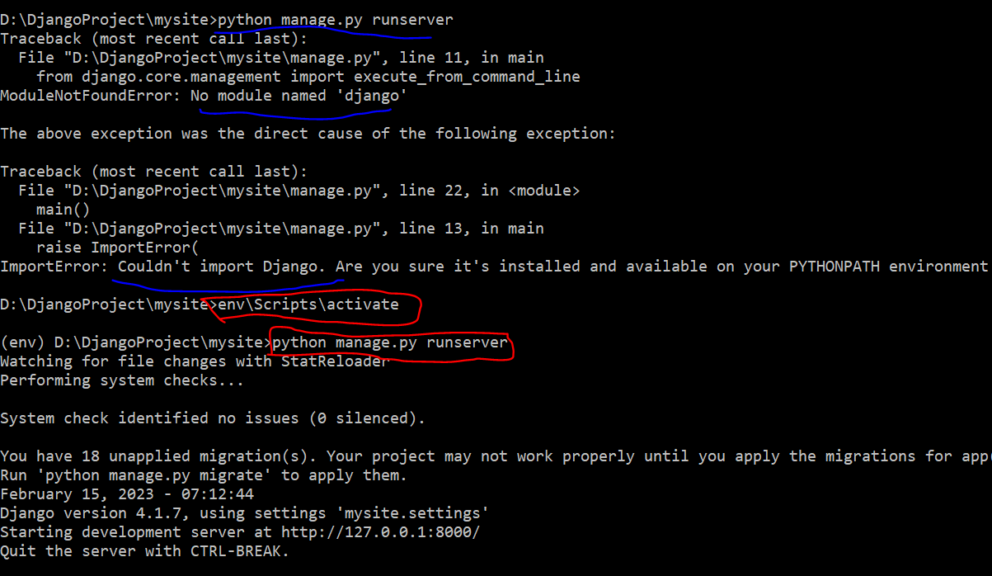

Complete guideline to ins(env) E:\DjangoProject\Journal\MBSTU_Journal>python manage.py startapp journal_app

In settings add the installed app name ,add the templates in the dirs.

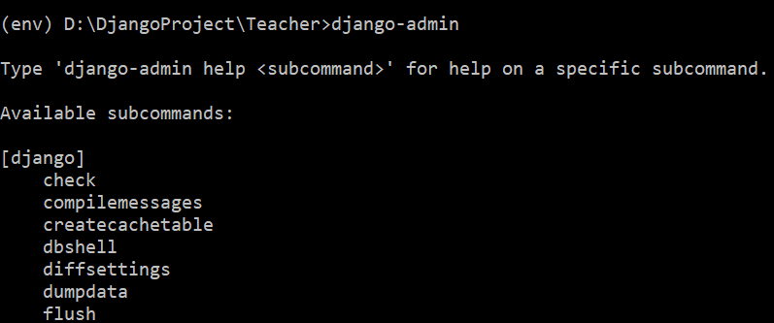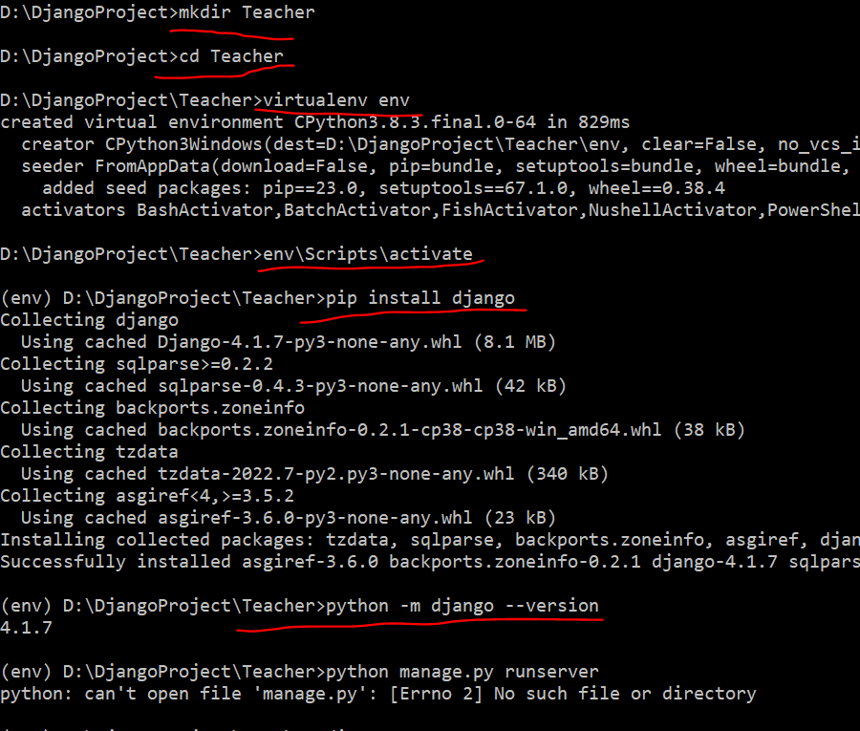



If the the app level template doesn’t find then check the project settings add the app name in installed apps

Project level template add -> go to settings then add os.path

After creating the model we need to register it in admin.py and use python mange.py makemigrations and python manage.py migrate command

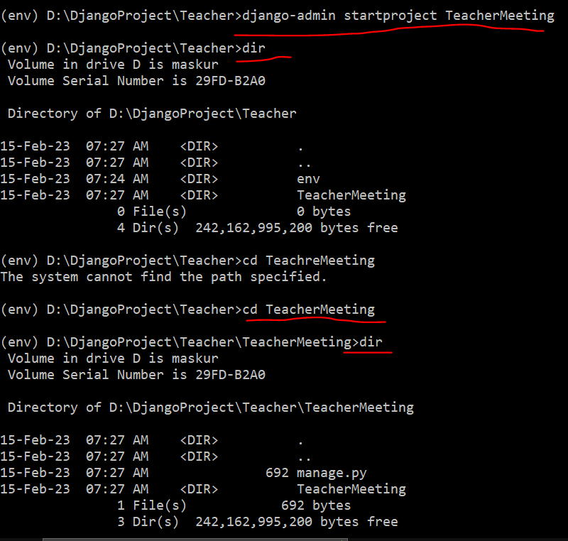

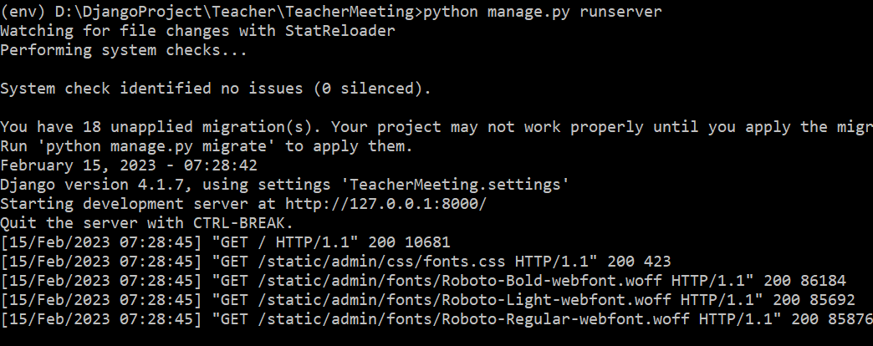

Now you can go to browser : 127.0.0.1:8000

After closing this terminal and again to start server go to the Teacher folder and activate the env by (env\Scripts\activate)

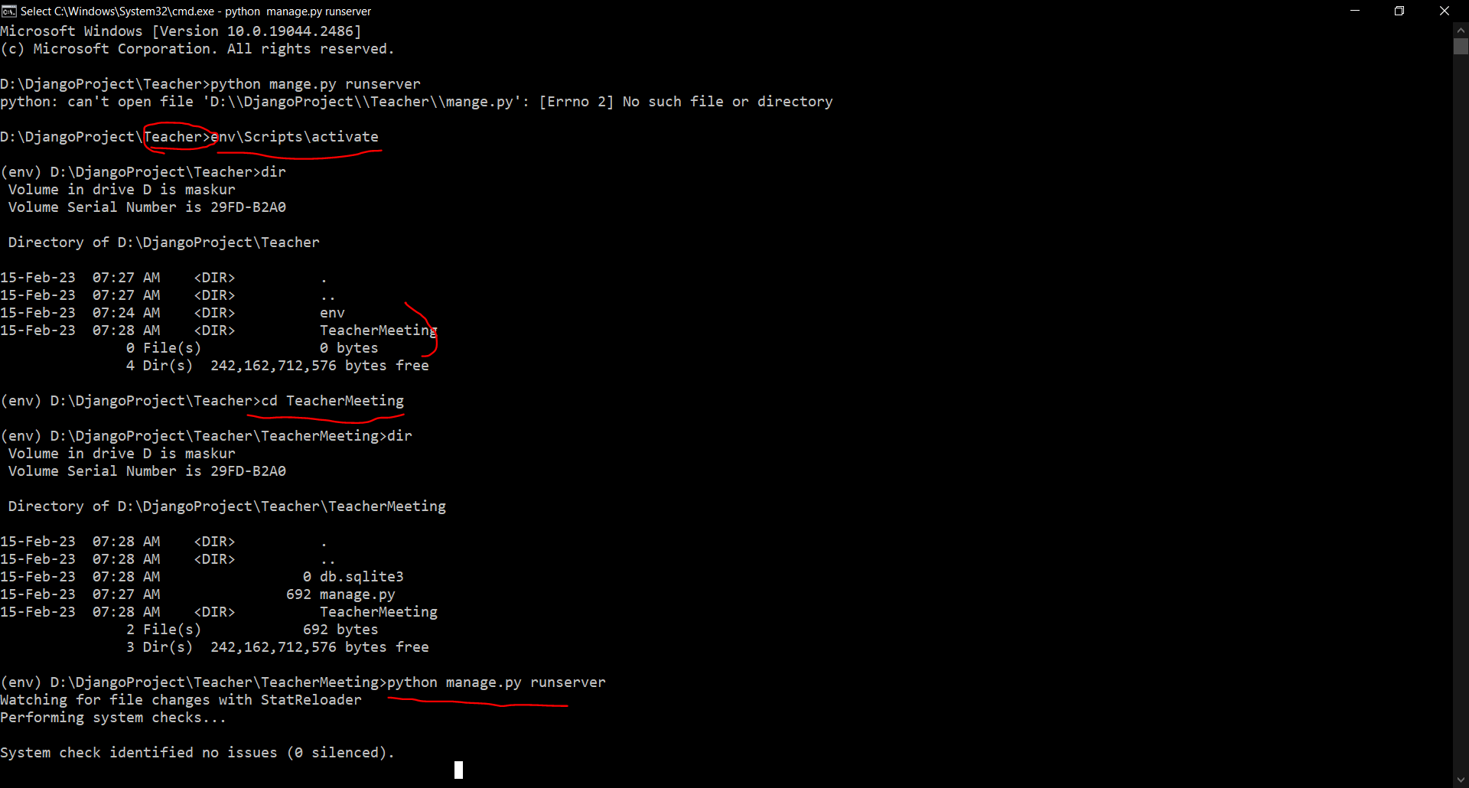

Base.html

<body>

{% block content %}

{% endblock content %}

</body>

Home.html

{% extends "base.html" %}

{% block content %}

<h1>Welcome</h1>

<p>This is the home page</p>

{% endblock content %}

Python manage.py migrate

Python manage.py createsuperuser

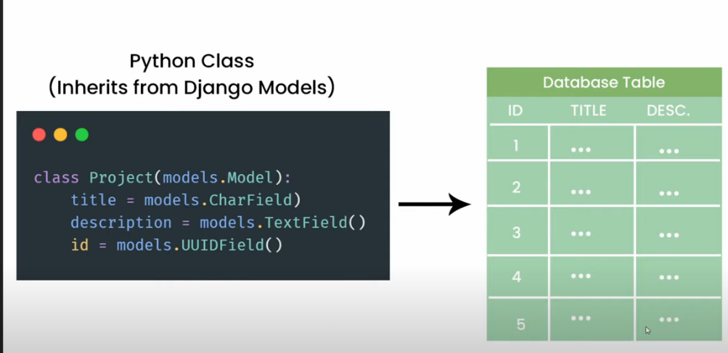

Python manage.py makemigrations

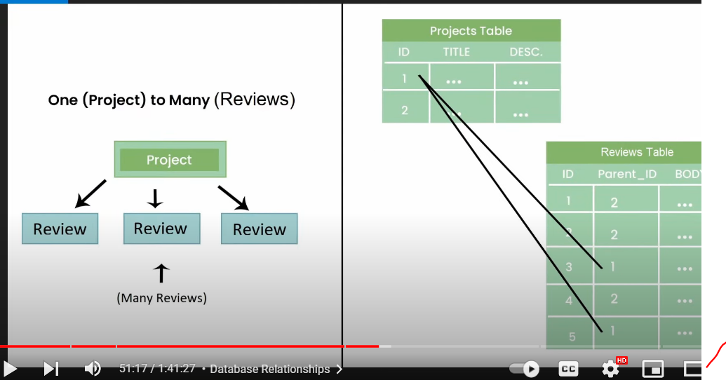

Linking url path in html page :

Two ways by url name or direct path

            <td> <a href="/project/{{project.id }}"> {{project.title }} </a></td>

Github:

Git status

Git add –a # it will add all file for commit

Git commit # this will commit all the file in local

Then there will be open a msg prompet in cmd to enter msg press (i) to close the editor press ctrl+c then type :wq

* Then to push the local commit to remote server send .
* Git push origin –main
* To add remote server use
* Git add remote “LINK of the project”

Add static file :

To do this create static folder in the project

Then add this folder in the setting.py

STATICFILES_DIRS = [

   BASE_DIR / 'static'

   #os.path.join(BASE_DIR,'static')

]

To set the upload image location use media root in setting:

MEDIA_ROOT = BASE_DIR / 'static/images'

Use the media url for user upload :

MEDIA_URL = '/images/'

Configure the urls in main project urls.py

urlpatterns+=static(settings.MEDIA_URL,document_root = settings.MEDIA_ROOT)

use a featured image field in database models

    featured_image = models.ImageField(null=True,blank=True)

we can access the image in html page directly :

<img style="max-width: 200px;" src="{{book.featured_image.url}}" alt="">

Or specifiy it in the function in models

define the function to return the file path of image to show in the html page

   @property

    def imageURL(self):

        try:

            img= self.featured_image.url

        except:

            img=''

        return img

in html to show the form we can use the shortcut :

{{form.as_p} or we can use custom way .

Use enctype=to submit pdf,image file

<form action="" method="POST" enctype="multipart/form-data">

    {% csrf_token %}

     {% for field in form  %}

        <div>

            {{field.label}}

            {{field}}

        </div>

      {% endfor %}

    <input type="submit" value="Create">

</form>

And we need to change the views.py where we add request.files

       form = ProjectForm(request.POST,request.FILES)

STATIC_ROOT= ADDED

DEBUG =FALSE FOR PRODUCTION

PYTHON MANAGE.PY COLLECTSTATIC

PIP INSTALL WHITENOISE